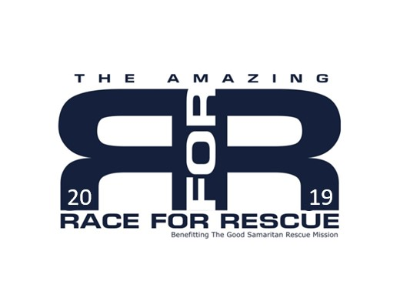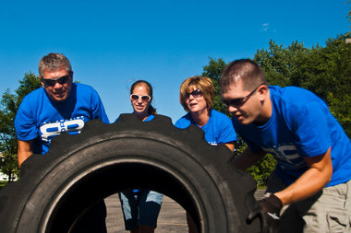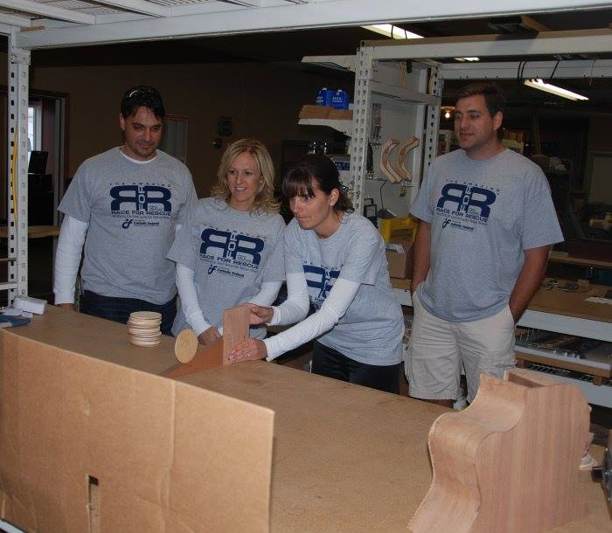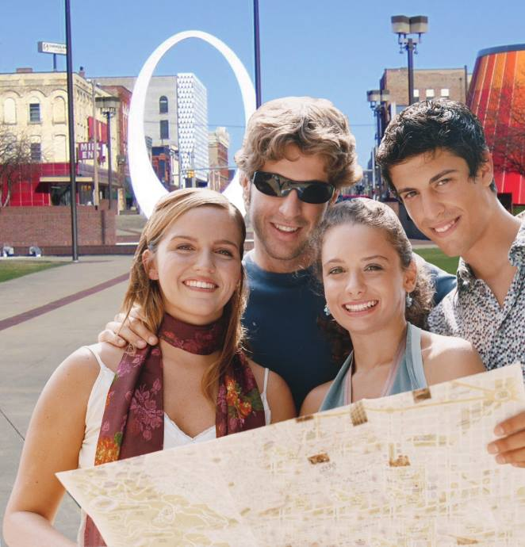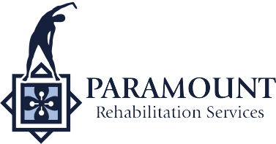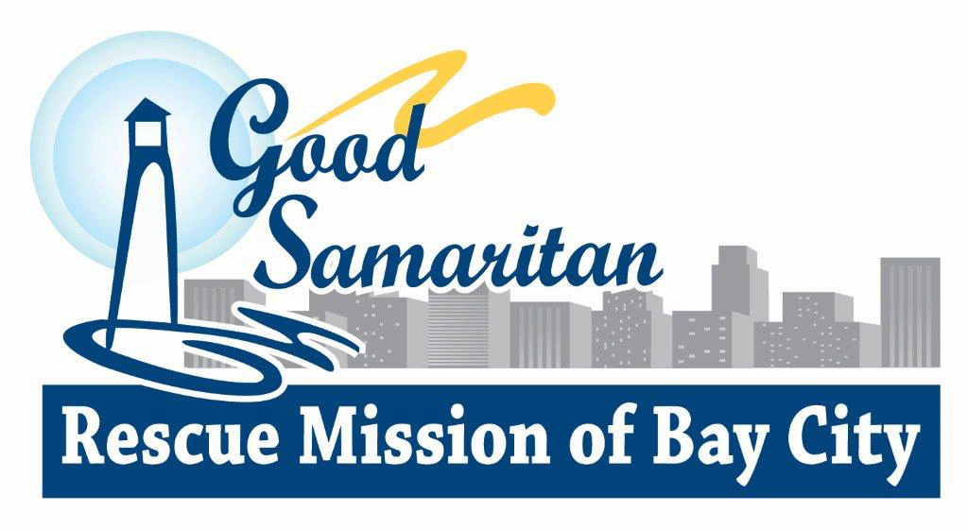

Since 2010, The Amazing Race for Rescue has seen 500 race participants raise over $82,000 for the Good Samaritan Rescue Mission.

PRESENTED BY:

BENEFITTING:

# How Can You Help?

There are multiple ways that you can help! One way is by providing a **tax-deductible sponsorship**. *Please see enclosed sponsorship level form for details on what is included at each level of sponsorship.* You can also donate a **silent auction item** for the Finish Line Festivities. Another way you can help is by **volunteering** with the preparation of this event or by **volunteering** on the day of the event.

The sponsor fee is completely tax deductible as a donation to the Good Samaritan Rescue Mission.

# What Are The Benefits of Sponsoring Race for Rescue?

Besides providing invaluable support to Bay City’s homeless, your business has the potential to greatly benefit from valuable community exposure. Race for Rescue sponsors benefit from many of the following elements depending on level of sponsorship: \***Media Exposure** through Race for Rescue Website, Facebook, Bay City Times, Cumulus Broadcasting \***Business mention on promotional materials** including event posters, billboards, participant T-shirts, silent auction dinner tickets and dinner program *A vital element of the “Race” is that all participants need to discover as much as possible about each sponsoring business in order to understand event clues. Your business is given the opportunity to be a “**sponsored stop”** on race day, enabling **over 100 participants into your business**.

# What Is Race for Rescue?

Race for Rescue is a fun, exciting road rally that raises awareness and funds for the Good Samaritan Rescue Mission. The event is based off of The Amazing Race TV show. Teams of four will experience the thrill of deciphering clues and completing tasks at area businesses as they make their way through Bay City. Participants will discover the great services and products our charitable businesses offer our community with the winning team receiving $1,000. The event will end with Finish Line Festivities celebrating those businesses and teams who worked together to help the homeless right here in Bay County.

RACE FOR RESCUE 2019

For more information contact: Paramount Rehabilitation Services- Jill Lenhard & Megan Monroe at (989)891-9800 or (989)450-0397  
[R4R@prsmichigan.com](mailto:R4R@prsmichigan.com) www.raceforrescue.org